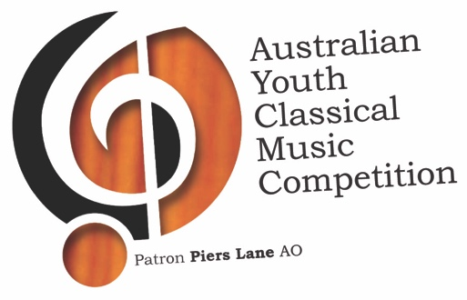
REGIONAL
30th Annual Competition

The Australian Youth Classical Music Competition is undertaken
by ACN 159 947 378 as trustee for
The Geelong Advertiser Music Scholarship Trust

Patron Piers Lane AO

REGIONAL APPLICATION 2020

APPLICANT DETAILS

Name

Address

Email

Phone

Date of birth Age on Tuesday 1 January 2020

Instrument

Last grade attained AMEB or equivalent
(expected minimum standard is Grade 6 or equivalent)

Current school

Name of Accompanist

Have you competed in this competition before? No Yes

APPLICANTS UNDER THE AGE OF 18

If you were under the age of 18 years of age on Tuesday 1 January 2020, the following declaration must be completed by your Parent / Guardian.

Name
Relationship to Applicant

I (Parent/Guardian of the Applicant) have read the Conditions of Entry for the Australian Youth Classical Music Competition and agree to be bound by those conditions and this application being made.

Parent/guardian email
Date

APPLICATIONS CLOSE MONDAY 6 APRIL 2020 - 5PM

APPLICANT DECLARATION

- I hereby apply for the Australian Youth Classical Music Competition
- I have read & understood the conditions of entry for the Regional Section
- I have lived at my principal residence in the municipalities of the City of Greater Geelong, Surfcoast Shire, Golden Plains Shire, Borough of Queenscliff, or the Colac Otway Shire for not less than 2 years within the period of 5 years immediately preceding their application OR I am currently a full time student at a school OR a music student studying with a music teacher residing within the above stated municipalities for a period of not less than 2 years immediately preceding this application
- I enclose or will transfer the non-refundable $25 entry fee for the competition
- I consent to perform at an audition on Saturday 9 May at Keith Humble Centre - The Geelong College
- If selected as a finalist, I will provide a biography, confirmed list of performance piece/s and program notes by Sunday 27 May
- If selected as a finalist, I agree to play at the Regional Finals Concert before an adjudicator and an audience on Sunday 31 May at Keith Humble Centre - The Geelong College
- If selected as the Regional First Prize winner, I agree to perform at the National Finals Weekend on Sunday 19 July and I will provide a recent quality colour photograph for the printed program
- I agree to abide by the rules of the Competition and accept the decision of the Adjudicators.

Date
Applicant email

How did you hear about this competition?

Poster/Flyer Newspaper Music teacher Word of mouth
School Uni/TAFE Facebook Website
Other

SUBMIT APPLICATION

Email this document (file) to admin@aycmc.org.au
and pay the non-refundable $25 entry fee via EFT to:

Geelong Advertiser Music Scholarship Trust Fund
BSB 063-512 Account No. 1023 9030
Reference (applicant’s name) be sure to include this

OR

Print this document and enclose a Cheque or Money Order payable to Geelong Advertiser Music Scholarship Trust Fund for the non-refundable $25 entry fee to:

Australian Youth Classical Music Competition
Project Coordinator
PO Box 1693
Geelong VIC 3220

